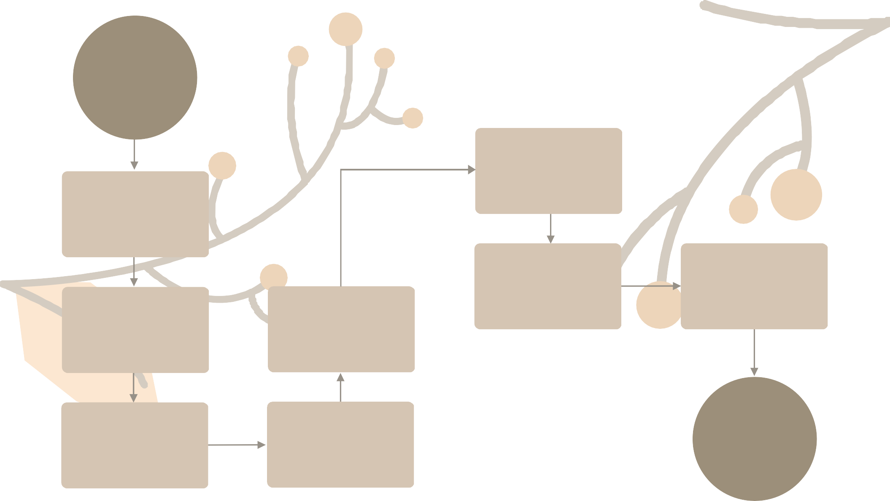

P R O J E C T M A N A G E M E N T W O R K F L O W
By Peter Lee

Project business case

Project execution by committee

Project review

Quality Assurance

Stakeholder engagement

Project revision
Progress report per tranche update

Budget, deliverables, and timeline planning

Review completion and approval

Review completion and approval

